Practical No: 4

Social Media Strategy for a Startup

By :- Vishal bhagat - 10323210222
Sultan Hussain - 10323210245
Priyanshu Tiwari - 10323210221
A startup is an entity, a new business that aims to grow quickly and become profitable.

- That is incorporated as a private limited company, a partnership firm, or a limited liability partnership (LLP).
- The entity has been operating for less than ten years from its incorporation or registration date.
- Whose turnover for any financial year since its incorporation has not exceeded INR 100 crore (approximately USD 14 million).
- That is working towards innovation, deployment, development, or commercialization of new processes, products, or services driven by technology or intellectual property.

How to target today's audience
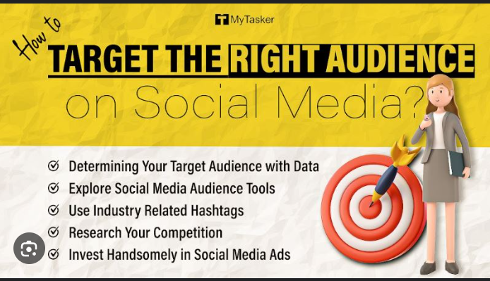

Here are some examples:

- Email: You might have a newsletter with tips that targets your general target audience, nurture email flows that target leads, and/or trigger emails aimed at current customers.
- Event: You might host an event for an entire community, like in the landscaping company example above, or instead one that caters to potential customers. You could even throw an event for current customers or prospective partners.
- Social media: You might share a thought leadership piece aimed at influencers who would share it, a how-to video for your potential customers, or you could host a series of interviews with figures notable for your audience—whether those are authors, celebrities, or experts.

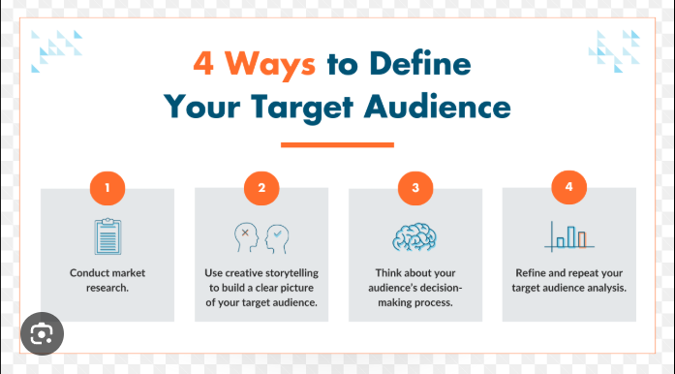

PROFILE DEVELOPMENT:

1.Choose a Consistent Username

Use the same handle or username across platforms whenever possible. This makes it easier for people to find you.

2.Profile Picture

Use a high-quality, professional photo. Ideally, it should be a headshot with good lighting and a neutral background.
Maintain the same or similar image across platforms for brand recognition.

3.Cover Photo/Banner

Select a cover photo that reflects your brand or professional identity. It could be a logo, a professional setting, or an image that conveys your industry.

4.Bio/Description
Write a concise and informative bio that clearly states who you are and what you do. Include relevant keywords for your industry.

5.Contact Information

Include a professional email address or a link to your website if applicable. Ensure this information is consistent across profiles.

Types of Content for Startups

Effective content marketing is essential for startups to build brand awareness, generate leads, and drive customer engagement. Here are some key types of content that startups can utilise:

Blog Posts

- Informative: Provide valuable insights, tips, and tutorials related to your industry. • Thought Leadership: Showcase your expertise and establish your startup as an authority.
- Case Studies: Highlight successful projects or customer stories to demonstrate your value proposition.

Social Media Posts

- Behind-the-Scenes: Give your audience a glimpse into your company culture and team.
- Product Demonstrations: Showcase your product or service in action.
- Customer Testimonials: Share positive feedback from satisfied customers.
- Engaging Content: Use polls, quizzes, and contests to encourage interaction.

Videos

- Explainer Videos: Clearly communicate your product or service's benefits.
- Customer Testimonials: Capture video testimonials from happy customers.
- Product Demos: Show your product or service in action.
- Educational Videos: Provide valuable tutorials or how-to guides.

Infographics

- Complex Data: Visualize complex data or statistics in an easy-to-understand format.
- Process Flow: Illustrate processes or workflows.
- Comparison Charts: Compare your product or service to competitors.

Email Marketing

- Newsletters: Keep subscribers updated on company news, product launches, and industry trends.
- Promotional Emails: Offer discounts, coupons, or limited-time promotions.
- Welcome Series: Onboard new subscribers and provide valuable resources.

HOW TO MAINTAIN CONSISTENT ENGAGEMENT:

- Establish a consistent posting frequency (e.g., daily, weekly). Stick to this schedule to keep your audience anticipating your updates
- Respond to comments, messages, and mentions promptly. Acknowledge feedback and thank followers for their input.
- Use polls and surveys to gather insights from your audience. This not only boosts engagement but also shows you value their input
- Use relevant hashtags to increase the visibility of your posts and attract a broader audience interested in your field.
- Regularly review your analytics to understand which posts resonate most with your audience. Adjust your strategy based on these insights.
PLATFORM SPECIFIC STARTUP STRATEGIES:

1.Facebook

Create a Business Page: Start by setting up a dedicated business page, ensuring all information is complete (bio, contact info, website).
Engage with Local Community: Join and participate in local groups relevant to your industry to connect with potential customers.
Run Targeted Ads: Use Facebook Ads to target specific demographics and interests related to your business.

2.Instagram

Visual Branding: Develop a cohesive visual theme (colors, fonts, style) for your posts to create an appealing grid.
Use Stories and Reels: Post regularly in Stories and create short Reels to engage your audience and showcase products or behind-the-scenes content.

Hashtag Strategy: Research and use relevant hashtags to increase visibility, including a mix of popular and niche hashtags.

3.Twitter
Join Relevant Conversations: Use Twitter’s search function to find and engage in trending topics and hashtags related to your industry.
Share News and Updates: Post regular updates about your business, industry news, and insights to establish thought leadership.
Network with Influencers: Engage with industry influencers by retweeting their content and mentioning them in relevant discussions.

4.LinkedIn

Optimize Your Profile: Create a comprehensive and professional profile, highlighting your skills, experience, and achievements.
Share Valuable Content: Post articles, insights, and industry news that add value to your connections and establish expertise.

Participate in Groups: Join LinkedIn groups relevant to your industry to connect with like-minded professionals and share your expertise.

TOOLS AND ANALYTICS:

Monitoring social media engagement is essential for understanding how your audience interacts with your content. A comprehensive tool like Sprout Social or Hootsuite can help you track and analyze this engagement effectively. Here’s how such tools work and how their analytics can inform your strategy adjustments:

1.Tool Overview: Sprout Social

Engagement Monitoring: Tracks likes, shares, comments, mentions, and direct messages across multiple platforms.
Dashboard Features: Provides a centralized dashboard to view engagement metrics in real-time.
Audience Insights: Analyzes demographic data, follower growth, and engagement patterns

2.Key Analytics Metrics

Engagement Rate: Measures the percentage of your audience interacting with your content.

Strategy Adjustment: If the engagement rate is low, consider experimenting with different content types, such as videos or polls, to see what resonates better. Reach and Impressions: Reach indicates how many unique users saw your content, while impressions show how many times your content was displayed.
Strategy Adjustment: If reach is high but engagement is low, the content might not be compelling. You might need to refine your messaging or visuals.

3.Informing Strategy Adjustments

Content Refinement: Regularly reviewing which content performs best helps you understand what your audience enjoys, allowing you to create more of that type.
Timing Adjustments: Analyzing when your audience is most active can help you schedule posts for optimal engagement.

Performance through analytics tool:

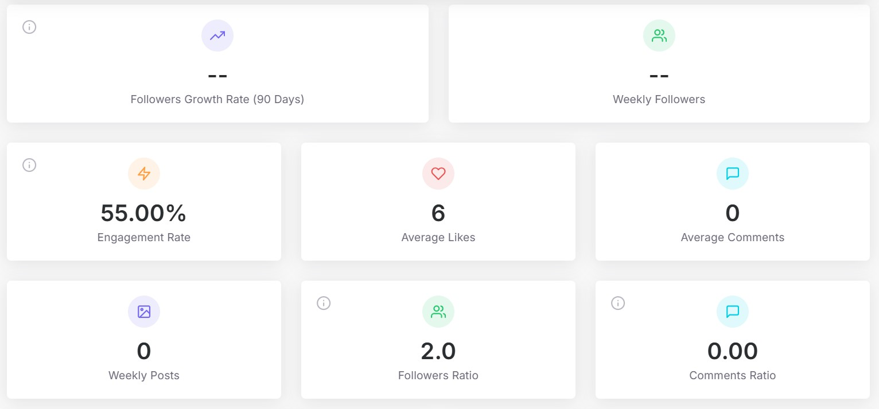

Performance of the through Instagram Insights:

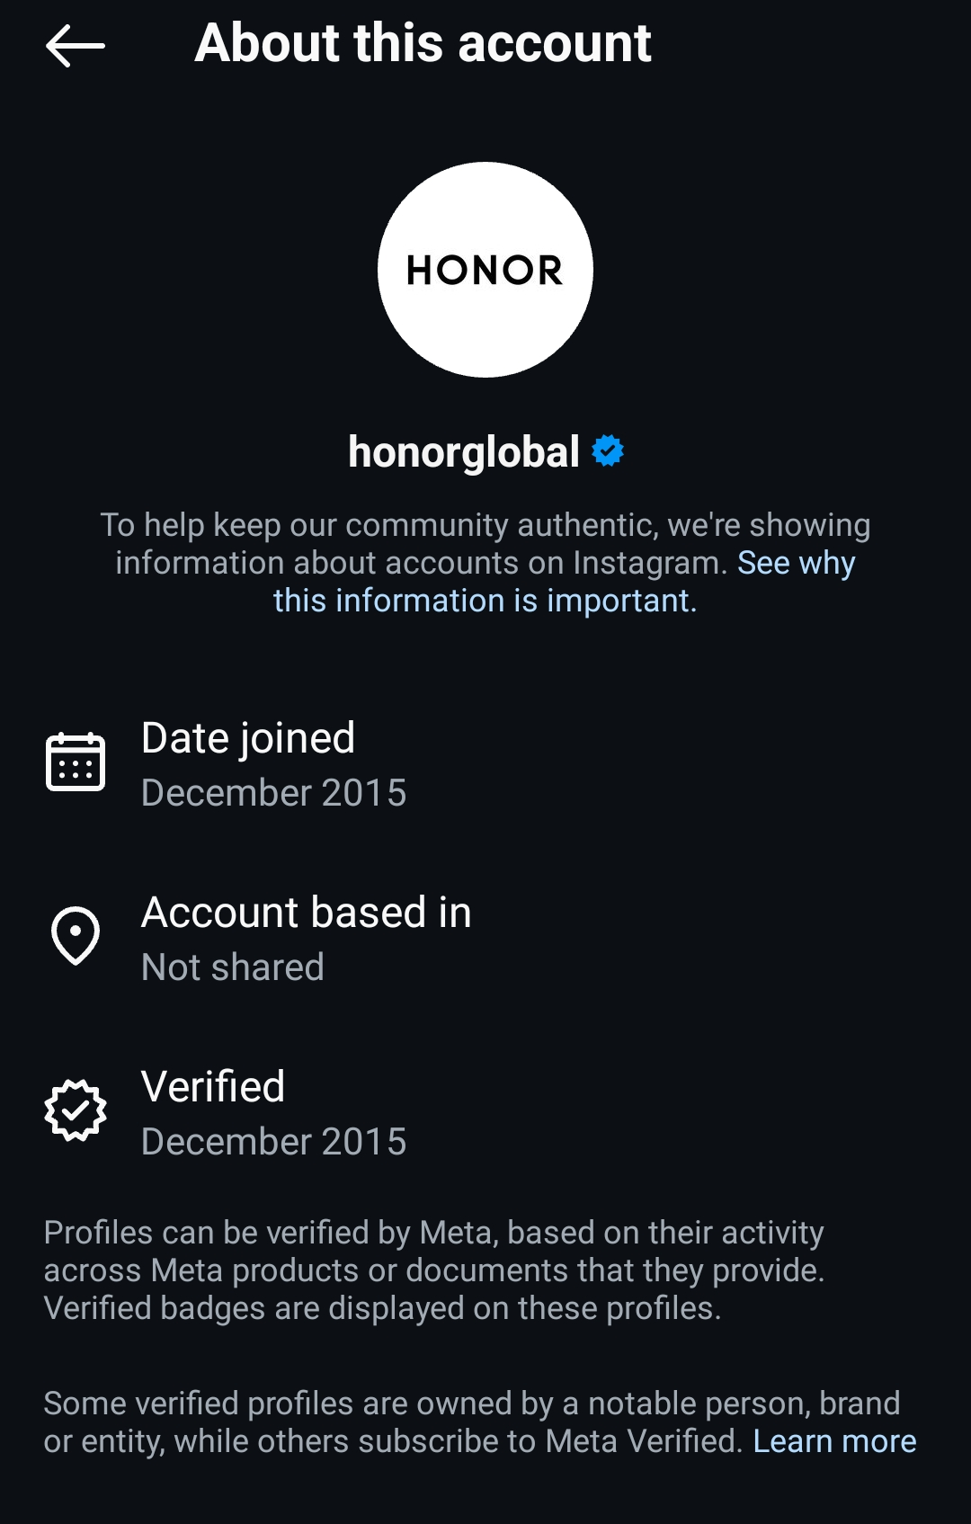
HERE IS AN EXAMPLE OF STARTUP THAT WE DID:

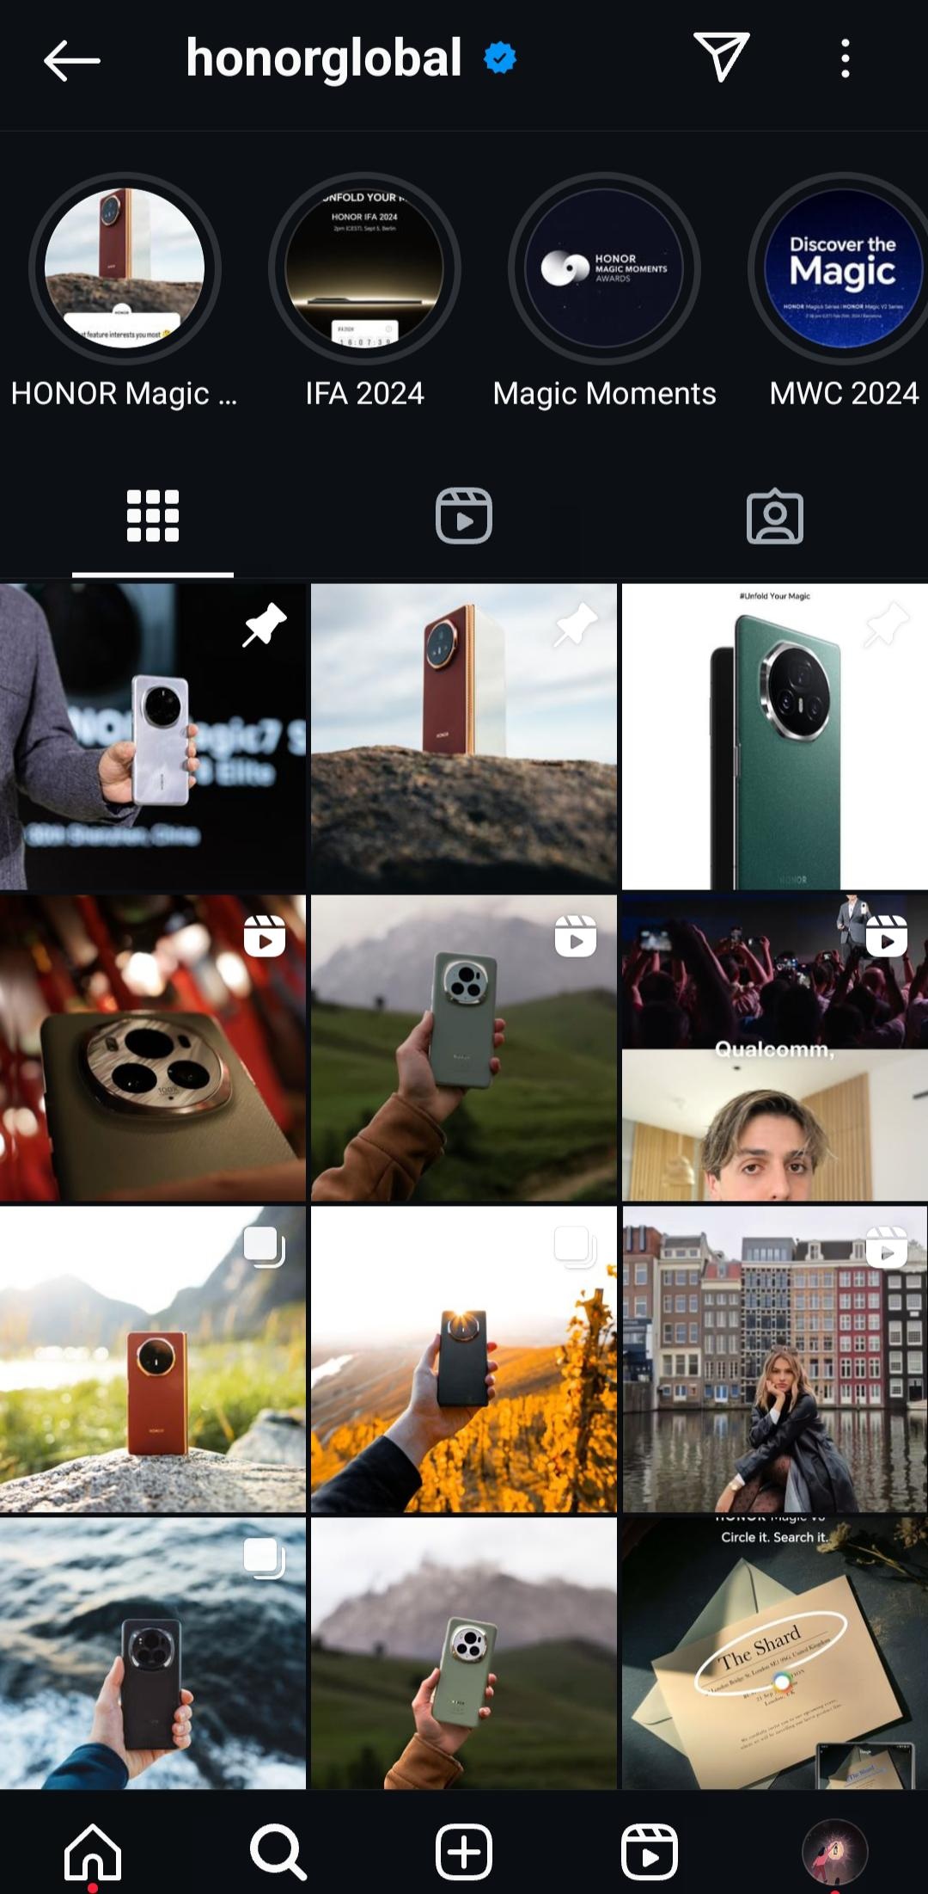

INSTAGRAM ID: promton_mobile_67

LINK OF A PAGE
https://www.instagram.com/promton_mobile_67/profilecard/?igsh=Yjcxcn RlazFob3p4

ABOUT THE STARTUP

Velvet Closet is a clothing brand that we made promoting various outfits for the upcoming generation which will suit the taste of the current as well as the old generation, at a very affordable price, providing high quality material to put smiles on everyone's face.

Through social media we can engage our product to various kind of customers and provide a vast table for our business to set up, it is through social media that we can easily promote our startups in today's generation targeting all kind so people that we want, by selecting and customizing our ads to be seen by the audience that we would like your product to reach, and that's why social media is a great way to promote one's start up easily.





Conclusion:

1.Brand Identity Development

Establish a strong, unique brand identity that reflects your target audience's values and lifestyle.
Create a cohesive visual aesthetic across all platforms (logo, colors, typography).

2.Target Audience Research

Identify and analyze your target demographic, including preferences, shopping habits, and social media usage.
Use insights to tailor marketing messages and product offerings.

3.Social Media Engagement

Utilize platforms like Instagram and TikTok for visually-driven content to showcase products.
Engage with followers through polls, questions, and user-generated content to build community.

4.Influencer Collaborations

Partner with fashion influencers to reach wider audiences and leverage their credibility.
5.Promotional Campaigns:
Launch limited-time offers, seasonal sales, or exclusive collections to create urgency and excitement.
Utilize email marketing to keep customers informed and engaged.

6.Expected Impact on Startup Growth:

Increased Brand Awareness: A strong social media presence and influencer partnerships will enhance visibility, attracting more potential customers.

Customer Loyalty and Community Building: Engaging content and direct interaction with followers foster a loyal community, encouraging repeat purchases.

Sales Growth: Optimized e-commerce and targeted promotional strategies are likely to drive higher conversion rates and sales.

Market Differentiation: A clear brand identity and commitment to sustainability can set the brand apart in a competitive market.

Long-Term Sustainability: By building a community around shared values and quality, the brand can establish a loyal customer base that supports long-term growth

